- Change ‘Nigerian Excellence’ to Premium Nigerian Ginger
- Remove EU compliant*
- Change intro message to ‘’We produce premium ginger products for buyers who demand consistency, traceability, and exceptional quality — from farm to freight.

- About Us
Edan & Sherr was founded on a simple conviction: Nigerian ginger is among the finest in the world — yet its true value has not been fully utilised. What has been missing is simple: a processing facility capable of preparing it to international standard, and a supply chain built to get it there. That is what Edan & Sherr was created to provide — a processing and supply chain that honours the farmer, respects the crop, and delivers a product worthy of the world's most discerning buyers.

From Southern Kaduna, Nigeria's premier ginger belt, we work directly with over 100 smallholder farming families providing fair farm-gate pricing, and guaranteed offtake. Our processing facilities then transform that raw material into export-grade products that meets EU, US, and Asian regulatory standards.

Remove claims from here.
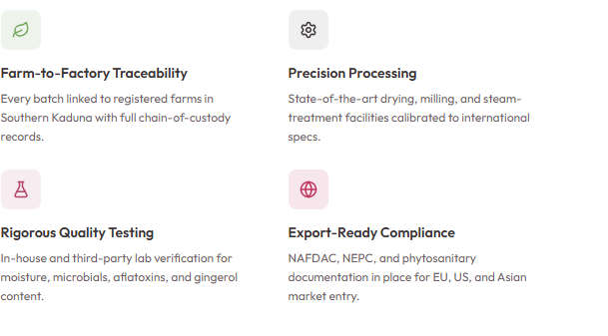
Our Products

Dried Split Ginger
Sourced from carefully selected fresh ginger roots in Southern Kaduna, sun-dried through a controlled process that preserves the natural potency, colour, and characteristic heat that makes Nigerian ginger exceptional.

Please Put products in boxes. Plus coming soon and register interest.
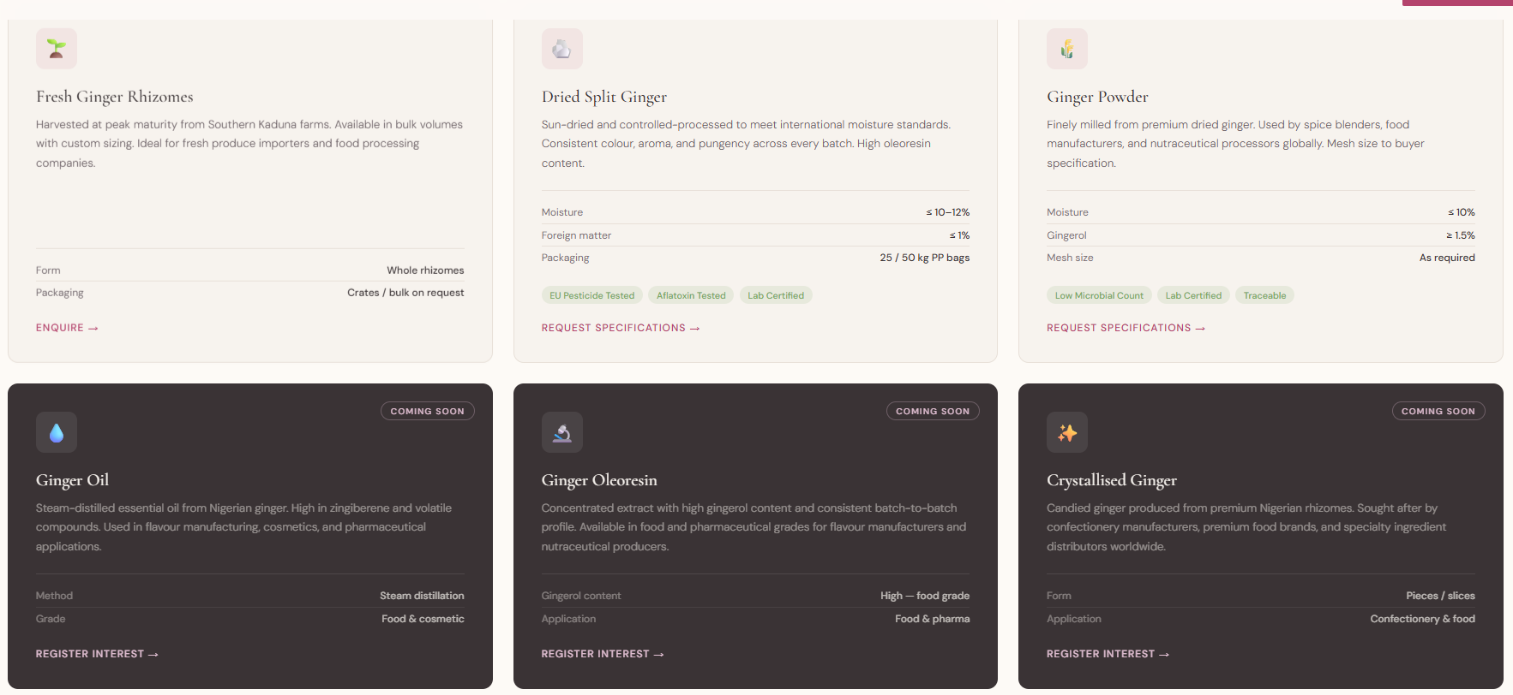

Our Story - Change to founder’s story

A Legacy of Ginger, A Vision for the World
She did not come to ginger through business. She came through the land — through a grandfather who devoted his life to it, and generations of farming families who understood, long before the world did, just how extraordinary Nigeria's ginger truly is.

Nigeria is home to some of the world's finest ginger, prized for its rich aroma, bold flavour, and exceptional oil content. For me, this is not a market opportunity. It is the land I grew up in, and the story of the people who shaped it.

My grandfather, one of the finest farmers of his time, devoted his life to the land. After him came my parents, uncles, cousins, and countless others — men and women who worked tirelessly in rich red soils under open skies, cultivating a crop that carries both heritage and pride. Season after season, they produced ginger of remarkable strength and character. What I still believe to be the boldest ginger in the world.

Yet despite its quality, much of its true value remained unrealised. The world had not fully experienced it as it should. I watched as each generation, in its own way, tried to bring this extraordinary resource to the global stage — often constrained by limitations beyond their control.

That is where the story begins to change. Edan & Sherr Limited was founded with a clear vision: to unlock the full value of Nigeria's world-class ginger and share its true potential with the world.

Quality You Can Verify
Full Traceability
Batch-coded processing records and chain-of-custody documentation provide complete, auditable farm-to-factory transparency.

Certifications Roadmap _ remove organic certification
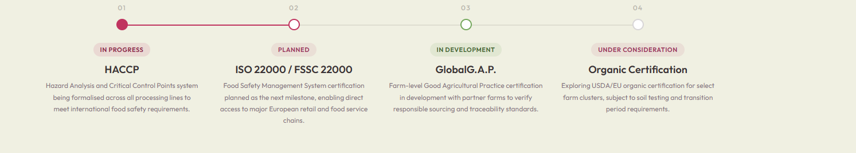

Can we put a page about Nigeria Ginger?

Why Nigerian Ginger
Not All Ginger Is Created Equal

Southern -Kaduna, Nigeria.
Where red laterite soils, high altitude, and an equatorial climate converge to produce the world's most prized ginger with qualities that cannot be replicated elsewhere. Bold aroma. Intense pungency. Exceptional oil content. Edan & Sherr brings you the best of it.

